Exp-7: Design a Task Management System for a small team in jira

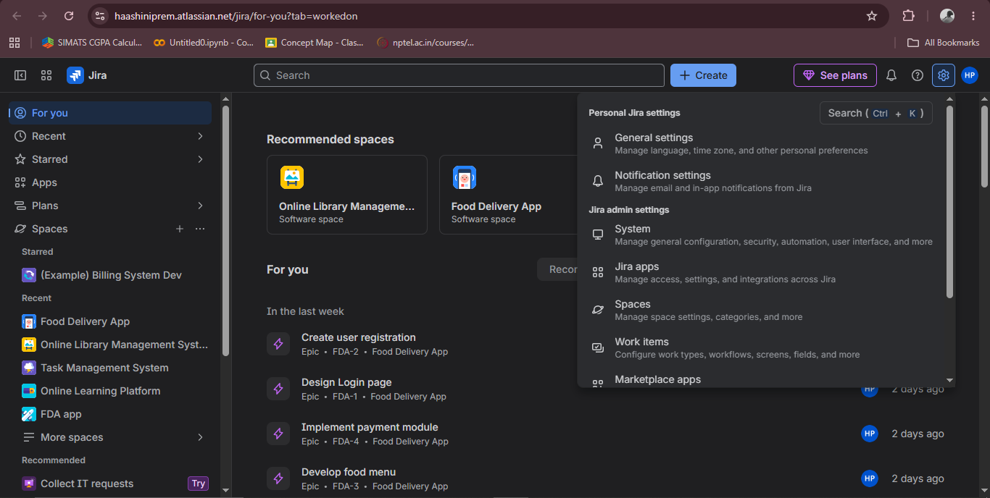
Step 1 – First we have to set the priority so go to settings in jira

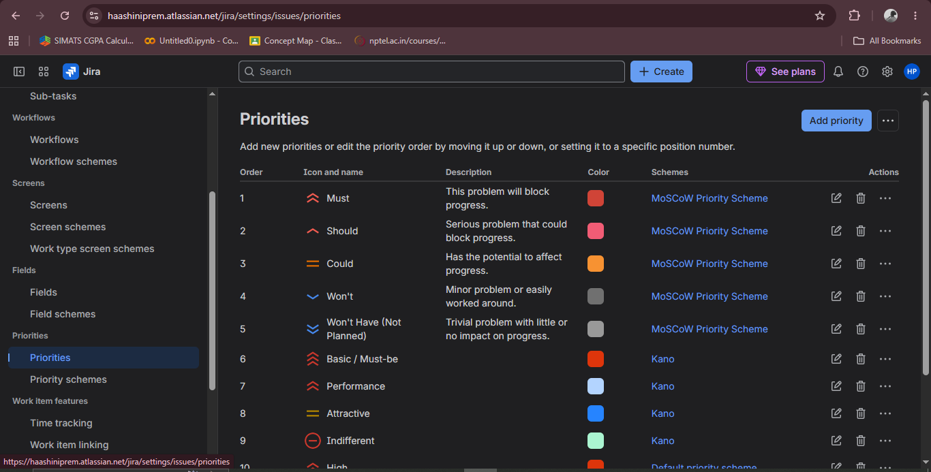
Step 2 – Click the work items then u enter a page select priority

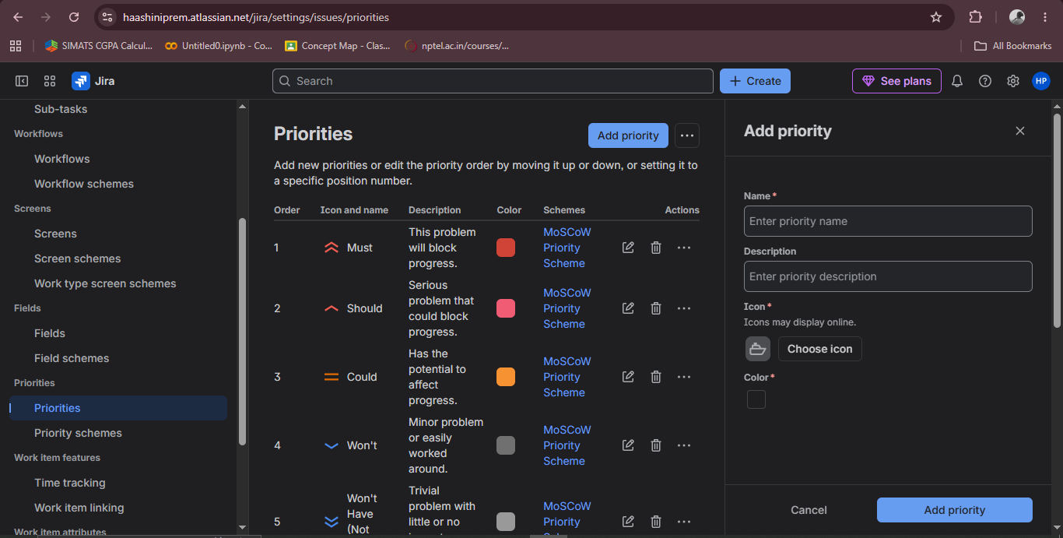
Step 3 – For adding new priorities click add priority and type them

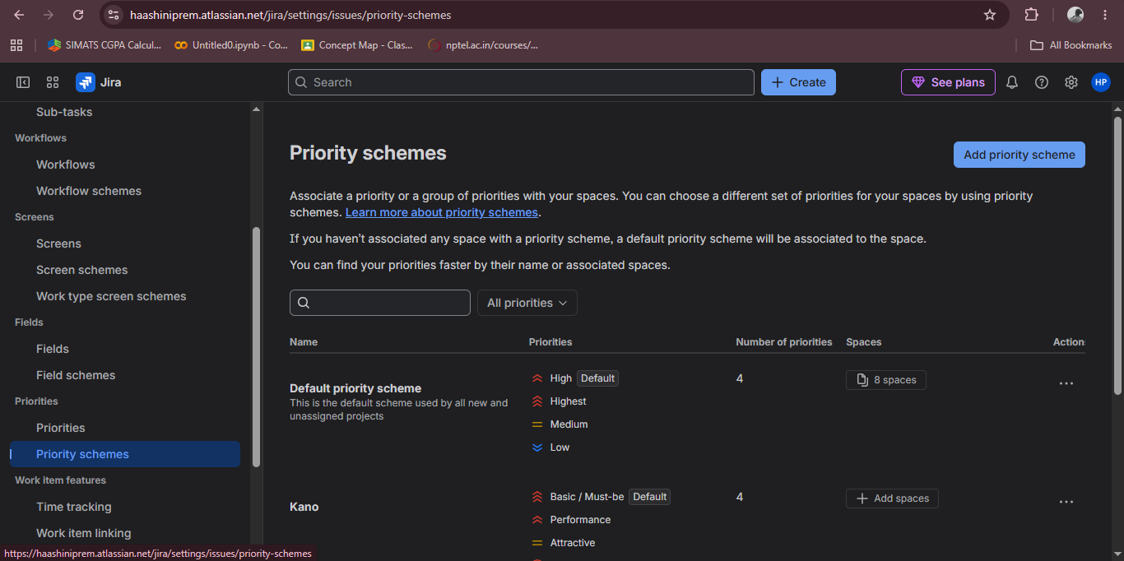
Step 4 – Then click priority schemes

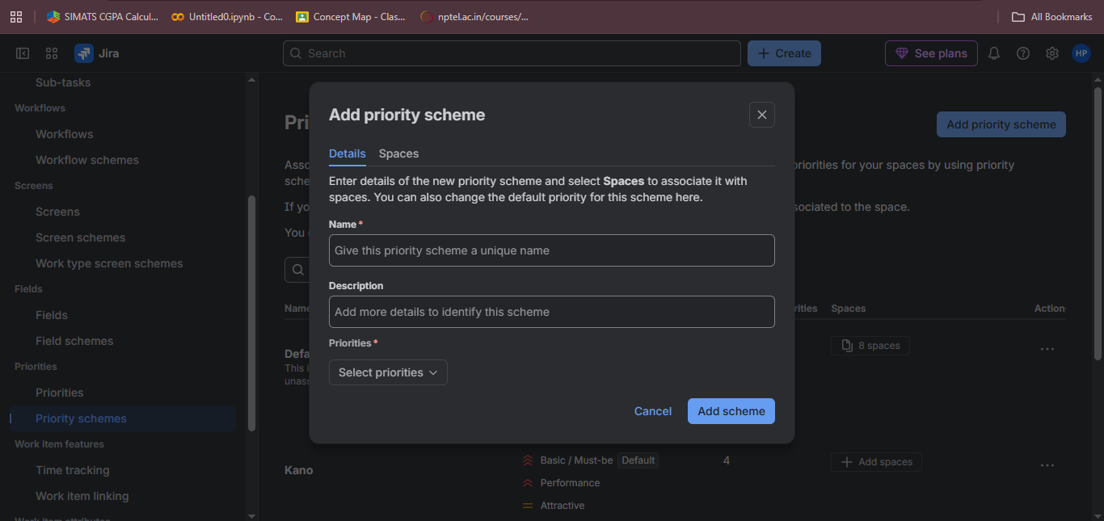
Step 5 – Create a new priority scheme and add the name

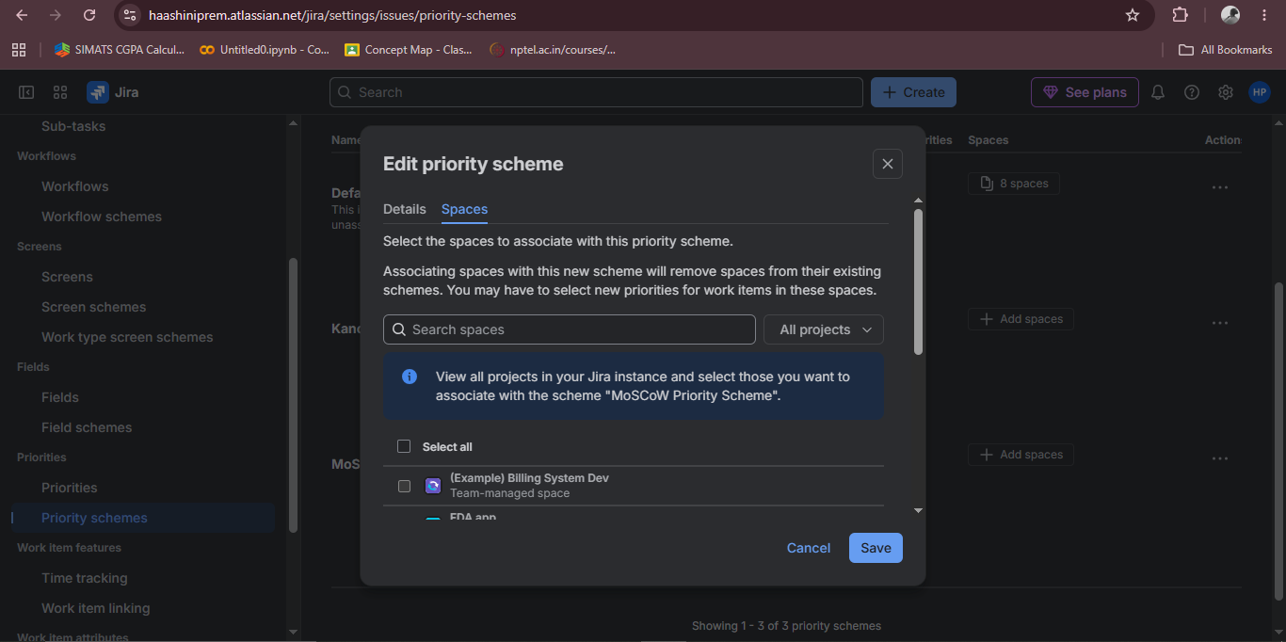
Step 6 – Click the (+) near the scheme and select the project to set the priority

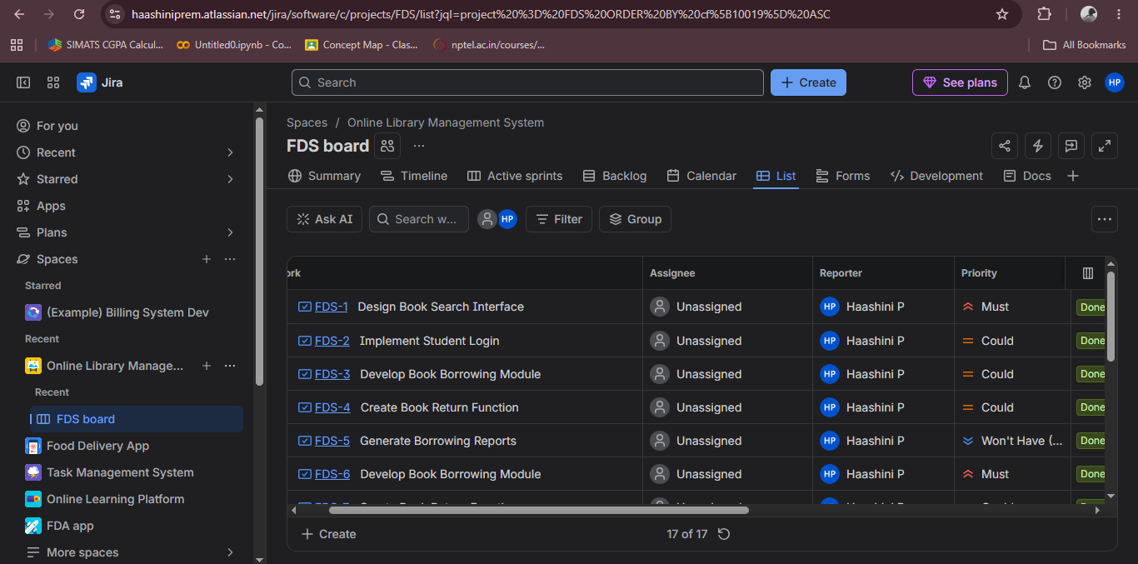
Step 7 – Now if u go to the project and click list u can see all the priority as Moscow

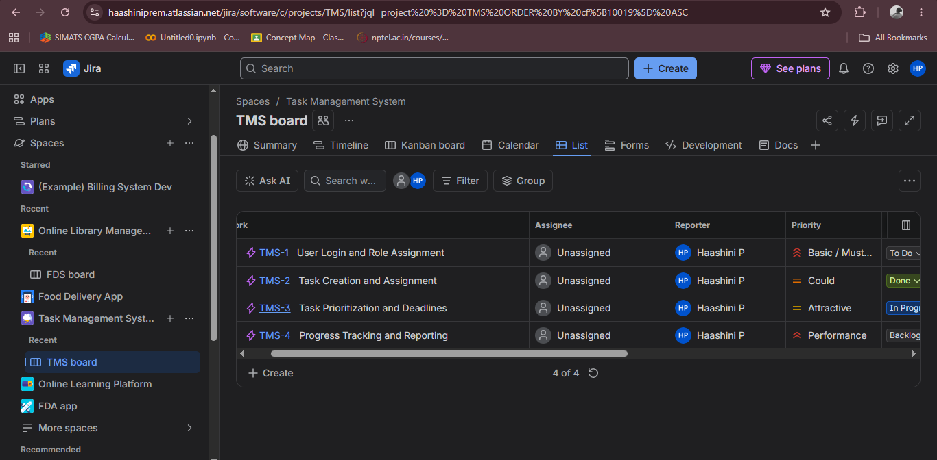
Step 8 – Same do for kano u will get displayed for it in the list

